Certified B2B Lead Generation Agency in Dubai |Generate More Qualified Leads Now
Has your brand failed to convert prospects into ready-to-buy customers? Don’t worry, our lead generation services can help you to capture consumer interest and convert it into sales by implementing target outreach and lead nurturing strategies. From B2B Lead generation to B2C Lead Generation, we are your one-stop solution to generate 10x times warm & cold based leads through a sales funnel hot approach. Request your custom lead gen proposal today to learn about pricing, strategies, and approaches.

Get In Touch!

Attain your Lead Targets With A Trusted lead generation company in Dubai!
Do you want to acquire new customers or target a new market in Dubai, UAE? The TAM lead generation team is perfect for this role. Our expert lead strategist will help you get more traffic by providing reliable data related to qualified contact through proper and legal channels.
From TAM, which is a certified lead generation agency, you can get:
- Transparency concerning Client Dealings
- More Organic Traffic & Qualified Leads
- Effective Content-Engaging Strategies
- More Return on Investment (ROI)
- Higher Conversion Rate
- Stack of Marketing and Analytical Automation Tools

Economical Lead Management Services In Dubai!
Have you ever wondered despite offering top-notch services or products, your brand fails to get desired lead goals? This happens when your business falls short of key lead management practices. It is where our Lead Generation agency steps in. The key to more sales and calls is at your hand. Just get our winning services to increase brand loyalty and capture more leads. We are an award-winning certified lead generation 24/7 ready to discuss your needs. Just get in touch today to transform your lead generation game.
Get a Free Consultation Now!

Performance-oriented Lead Generation Process!
A Winning Choice for Qualified Leads
Lead generation is not about quantity but all about quality. At TAM, we help you get more leads by putting your brand on the right track. It is a perfect opportunity for you to bridge the gap between your marketing and sales channels and revolutionize your lead game. Moreover, Our qualified experts will manage all your lead generation campaigns and convert them into a winning choice for your business. Through our proven marketing methodology, we will set up your campaign on a positive note and make sure your business generates more leads and converts them into sales.

Define Targets | Set Goals
In the first step, our lead experts define realistic and achievable targets which include customers' tastes, engaging strategies, and effective channels. In this way, we create feasible and realistic goals for acquiring leads. | After a proper understanding of clients and the market, we create measurable goals to achieve lead targets. Through this strategy, we can easily get an idea about the probability of success along with ROI.
Identify Channels | Monitor Progress
Once goals are set then we are ready to choose the relevant marketing channels such as LinkedIn Ads, SEO, SMM, Facebook & Instagram Ads, email outreach, and Re-targeting Ads to attain goals of lead generation. | After finalization of channels, our experts follow all relevant content marketing strategies and proceed towards the monitoring and analysis phase. In this way, we check the performance of our lead generation campaigns.

Let’s Turn Your Digital Marketing Into Proper Sales Pipelines!
You often interact with different lead generation companies in Dubai, when you searching for qualified leads. You don’t have to worry about leads at all when you partner with the right agency. Don’t worry, our lead generation services won’t disappoint you when it comes to turning marketing strategies into proper sales channels. We craft customized methods that suit well to the needs and requirements of your business. Together with us, you can get a 500% boost in ROI.

Moreover, we also have a proper lead generation package store for your needs. In this way, you don’t have to hire the services of separate marketing and sales managers. We will make lead generation more convenient and possible for you than ever before. If you are truly interested in hiring the most qualified lead generation agency in Dubai, you won’t find a more economical and better option than Three Angle Marketing (TAM). Your success journey is truly one call away so don’t feel hesitant just book a free consultation session to discuss your needs.

Schedule A Meeting!

What Makes Three Angle Marketing (TAM) A Reliable Partner For Qualified Lead?
One of the major goals of every brand is to leverage all organic and paid channels to attract more customers and generate better leads. TAM's expertise in the matter of lead generation is attributed to its personalized strategies that help brands in Dubai as well as in the UAE to create customized campaigns to engage more customers. During our customer's journey phase, our lead strategist optimizes every single step ranging from lead magnets, lead generation, and targeted PPC ads to conversion rates.

Multi-Channel Approach | Lead Nurturing | Continuous Optimization
To maximize customer engagement and brand reach, we follow a holistic approach which is a blend of digital marketing channels such as SEO, Email Marketing, and SMM. | TAM activities are not just limited to lead generation but play a significant role in lead nurturing too. For that purpose, we customized our channels and content to generate more sales. | Our lead experts constantly monitor our lead strategies and performance metrics to optimize all lead efforts with one single aim to maximize Return on Investment (ROI).
Targeted Outreach | Data-Driven Tactics | Quality Assurance
In order to attain the confidence of key stakeholders of relevant businesses, we implement highly targeted outreach strategies to help our clients. | By focusing on relevant marketing channels and content marketing strategies, we refine every single lead strategy through the use of analytical data tools. | In the end, to get more qualified lead contacts with an aim to convert them into loyal customers, we prioritize quality over quantity during every phase of lead generation.

Ready to Outpace Your Competitors?
All you need to do just schedule a session with our experts and leave the rest to us. Our lead generation model is very straightforward and can solve your revenue problems with ease. Let’s Contact TAM, the best in the market, to say goodbye to poor lead generation strategies.
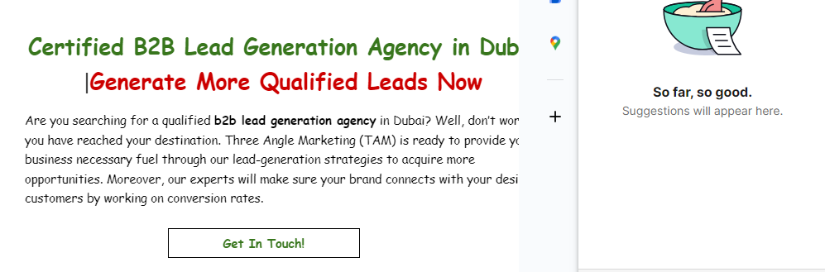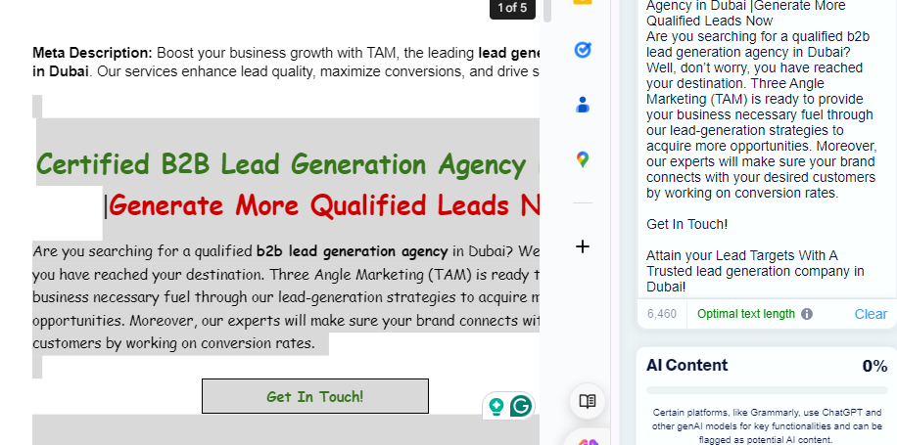

B2B Lead Generation FAQs
- Is lead generation a time-consuming process?
Lead generation actually takes time, but the identification of the right strategies and suitable instruments makes the task easier and benefits from the results.
- What is B2B lead generation?
B2B lead generation means the task of identifying potential clients for doing business who have the intention to buy business products or services.
- What is involved in a B2B lead generation campaign?
A B2B lead generation campaign includes researching the market, knowing who you will be marketing to, creating the marketing message/materials in various formats and media, targeting qualified prospects with the created content, and finally measuring the success of the entire campaign.
- What channels are used in B2B lead generation strategies?
It requires the use of various common media channels, such as email marketing, social media marketing, content marketing, SEO, PPC, and webinars.
- Why is B2B lead generation crucial for Dubai-based businesses?
For Dubai-based businesses, B2B lead generation facilitates access to local and global markets, expanding their client base for growth.
- What types of leads do B2B lead generation services provide?
B2B lead generation services produce various kinds of leads, such as marketing qualified leads (MQLs), sale qualified leads (SQLs), and product qualified leads (PQLs).
- What industries are common targets for B2B lead generation companies in Dubai?
The industries targeted are primarily property, financial, IT, medical, tourism, and hospitality businesses.

